Practical No. 3
Aim : 4) WAP to find the square root of a number.

Name : Danish Altaf Solkar | Class : CO - B
Enrolment no. : 24111590805 | Batch : 2

Code :-
num=float(input("\nEnter a number: "))
sqrt=num**0.5
print("\nSquare root of ",num," is ",sqrt)

OUTPUT :-
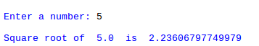

Process related  (30) | Product related  (20) | Total Marks  (50) | Signature

